Plenary: Sequence the sounds

To set up
- You will need ten volunteers from the class
- Eight learners are to be given one of the words or picture cards. Their job is to speak/ sing/ act out the words on the cards when told to by the conductor.
- One learner/ teacher will be the composer who will order the cards
- One of the learners is to be the conductor and will point at each learner in turn to inform them when to perform their sound. Inform the conductor that they must make sure this is a good performance and if they’re not happy with how the learners have performed they can teach the learner how they would like it performed.

Instructions
- Ask the composer to arrange the learners with the cards in a sequence
- The conductor should then run their program by pointing at them in turn. When they are being pointed at, the learner must perform their sound.
- Two of the learners have picture cards instead of word cards. What did they do? Did they convert the image into a sound or did they not do anything and were confused? This is a point where you can ask the rest of the learners in the class what should they have done? Remember computers don’t behave like humans and ‘guess’ what to do. If it doesn’t understand the instruction it can’t perform it.
- Debug the sequence and ask the learners with the pictures to sit down

If time
Selection:

- Ask the composer to order the cards in the following sequence: boing, bang, boom, wow, splat, kerpow
- Introduce the ‘If’ card and ask for another volunteer to stand between ‘Boom’ and ‘Bang’
- Tell the composer to move the classmates holding ‘Wow’ and ‘Splat’ to take a step forward, and the learner holding ‘Kerpow’, to take a step backwards but be behind ‘Wow’ (the idea is that the learners can visually see branching)

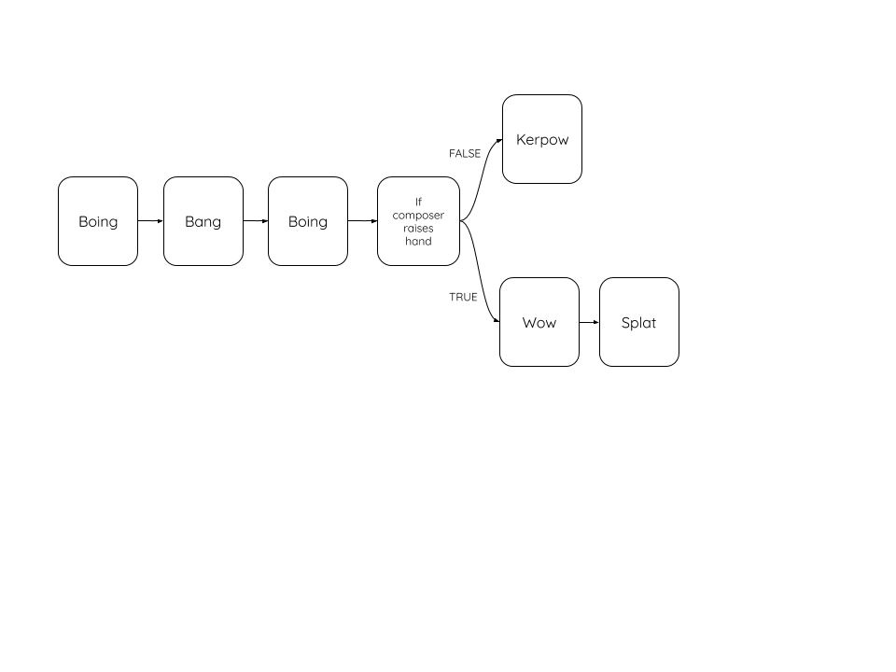

- Ask the conductor to play the sequence, when they have reached ‘Bang’ they should check to see if the composer has raised their hand or not and to follow the appropriate path. Highlight to the learners that this is selection. You might want to run this again, but this time remove ‘bang’ and the conductor should branch the other way and instruct ‘Kerpow’ to play.

Iteration:

- Remove the branch and the ‘If’ card and ask the conductor to make the learners play out the sequence four times. This time the job of the conductor is to only say “Start” at the beginning and then “Stop” once the learners have played their sound four times. Ask the learners how they might stand to make it easier (circle) before they start. Highlight to the learners that this is iteration.

SAY:

“BOING”

SAY:

“BANG”


SAY:

“WOW”

SAY:

“SPLAT”

SAY:

“KERPOW”

SAY:

“BOOM”

IF Composer raises hand:
Play Wow, Splat

ELSE:
Play: Kerpow

Lion image source: https://pixabay.com/photos/lion-predator-mane-big-cat-yawn-3317670/

Splash image source: https://pixabay.com/vectors/glop-goo-goop-grunge-gunk-ink-2026811/

Resources are updated regularly — the latest version is available at: ncce.io/tcc.

This resource is licensed under the Open Government Licence, version 3. For more information on this licence, see ncce.io/ogl.

